SIMATS ENGINEERING
ASSESSMENT TOOL 1

COURSE NAME: Artificial Intelligence COURSE CODE: CSA1708

COURSE OUTCOME COVERED

CO3: Analyze knowledge representation and reasoning using propositional logic, FOL, inference, resolution, chaining methods, knowledge representation to perform logical reasoning for drawing valid conclusions and decision making. (BL4)

Assessment Tool Weightage: 50%

Time Duration: 1 Hour

QUESTIONS: 4 Total Marks:40

Annexure A

CASE STUDY

Code of Conduct:

I N.JOE JERISH (192524374) certify that this submission is my original work and that I have adhered to the guidelines specified for this assessment.
I understand that any violation of academic integrity rules will result in disciplinary action.

Signature of the student:

Annexure A

CASE STUDY

Case Study 1 — Smart Medical Diagnosis System
A hospital is designing a rule-based Logical Agent for preliminary patient diagnosis. The system’s knowledge base contains:
I. If a patient has Fever AND Cough → Possible Flu
Ii. If a patient has Fever AND Rash → Possible Measles
Iii. If a patient has Cough AND Breathlessness → Possible Pneumonia
Iv. Facts about Patient A: Fever = True, Cough = True, Breathlessness = True
(a) Represent the above rules and facts precisely using Propositional Logic symbols. Define each symbol used.
(b) Apply Forward Chaining on the knowledge base to derive all possible diagnoses for Patient A. Show each inference step with the rule fired and fact derived.
(c) The goal is to confirm ‘Patient A has Pneumonia.’ Apply Backward Chaining and draw the goal reduction tree to verify this goal.
Case Study 2 — Autonomous Traffic Management Agent
A smart city traffic controller uses a FOL-based knowledge base to manage emergency vehicle routing:
- ∀x: Vehicle(x) ∧ EmergencyType(x) → ClearPath(x) [Rule 1]
- ∀x: ClearPath(x) → GreenSignal(x) ∧ ¬RedSignal(x) [Rule 2]
- ∀x ∀y: Vehicle(x) ∧ Behind (x, y) ∧ GreenSignal(y) → Proceed(x) [Rule 3]
- Facts: Vehicle (Ambulance), EmergencyType (Ambulance), Vehicle (CarA), Behind (CarA, Ambulance)
(a) Apply Unification to match Rule 1 with the given facts. Show the complete substitution set θ (MGU) at each step.
(b) Using the Resolution method, prove that ‘Proceed (CarA)’ is true. Convert relevant clauses to CNF and show each resolution step.
(c) Analyze whether the current FOL knowledge base is sufficient to handle two simultaneous emergency vehicles. Identify what additional rules or facts are needed and justify logically.
Case Study 3 — Agricultural Expert Reasoning System
An agricultural advisory logical agent operates with the following propositional knowledge base (KB):
- P1: SoilDry → IrrigationNeeded
- P2: IrrigationNeeded ∧ CropWheat → ApplyDripMethod
- P3: ¬ApplyDripMethod ∧ CropWheat → CropAtRisk
- Facts: SoilDry = True, CropWheat = True
(a) Convert all sentences P1, P2, P3 and the facts into Conjunctive Normal Form (CNF). Show each conversion step (eliminate implication → move ¬ inward → distribute).
(b) Using Resolution Refutation, prove the theorem ‘ApplyDripMethod’. Negate the goal, combine with the KB in CNF, and derive the empty clause □. Draw the resolution proof tree.
(c) If the fact ‘SoilDry’ is removed from the KB, analyze step-by-step how logical conclusions change. Does ‘CropAtRisk’ still follow? Apply appropriate reasoning patterns to justify.

Case Study 4 — Wumpus World Knowledge Agent
An AI agent navigating the Wumpus World perceives: Stench at [1,2], Breeze at [1,1], Glitter at [2,2]. The agent uses a propositional KB with these rules:
- Stench [1,2] → Wumpus is adjacent to cell [1,2]
- Breeze [1,1] → Pit is adjacent to cell [1,1]
- Glitter [x, y] → Gold is at [x, y]
- ¬Wumpus [x, y] ∧ ¬Pit [x, y] → Safe [x, y]
(a) Construct the agent’s belief state from its percepts. Apply Modus Ponens systematically to derive new knowledge facts. List all derived conclusions.
(b) Using Forward Chaining from the agent’s percepts, identify the possible locations of the Wumpus and Pit. Show each reasoning step precisely.
(c) Evaluate whether the path [1,1] → [1,2] → [2,2] is safe for the agent to collect the gold. Use the knowledge derived in (a) and (b) to justify your conclusion with logical inference.

RUBRICS FOR CALCULATION

Criteria | Weightage | Level 4 – Exemplary | Level 3 – Proficient | Level 2 – Developing | Level 1 – Beginning
Understanding of Case | 25 | Thorough understanding; clearly identifies all key issues | Good understanding with most issues identified | Basic understanding; some issues missed | Poor understanding; problem not identified correctly
Application of Concepts | 25 | Effectively applies relevant concepts to analyze the case deeply | Applies appropriate concepts with minor gaps | Limited application of concepts | Fails to apply relevant concepts
Analysis | 20 | In-depth analysis with strong reasoning and insights | Good analysis with logical reasoning | Basic analysis with limited depth | Weak or no analysis; lacks reasoning
Solution Design | 20 | Innovative, feasible solutions with strong justification | Logical solutions with adequate justification | Basic solutions with weak justification | Incorrect or no solution provided
Clarity | 10 | Clear, well-structured, and easy to understand | Organized and understandable presentation | Limited clarity and structure | Poor clarity; difficult to understand

CASE STUDY 1 — Smart Medical Diagnosis System
Part (a)
Symbol definitions:
Symbol | Meaning
F | Patient has Fever
C | Patient has Cough
R | Patient has Rash
B | Patient has Breathlessness
Fl | Possible Flu
M | Possible Measles
P | Possible Pneumonia

Rules in Propositional Logic:
Rule i: F ∧ C → Fl
Rule ii: F ∧ R → M
Rule iii: C ∧ B → P
Facts for Patient A:
F = True, C = True, B = True (R is unknown)
Part (b)
Forward Chaining — deriving all possible diagnoses for Patient A:
Step | Rule Fired | Condition Check | Fact Derived
1 | — | Initial facts asserted | F = True, C = True, B = True
2 | Rule i: F∧C→Fl | F=True and C=True ✓ | Fl (Possible Flu) derived
3 | Rule ii: F∧R→M | F=True but R=Unknown ✗ | Rule cannot fire — M NOT derived
4 | Rule iii: C∧B→P | C=True and B=True ✓ | P (Possible Pneumonia) derived

Final derived diagnoses for Patient A: Possible Flu (Fl) and Possible Pneumonia (P).
Part (c)
Backward Chaining — goal: 'Patient A has Pneumonia' (Goal = P):
- Start at goal P. Find a rule whose conclusion is P → Rule iii: C ∧ B → P.
- Reduce goal P into two sub-goals: C (Cough) and B (Breathlessness).
- Check sub-goal C against the facts: Cough = True → sub-goal proved.
- Check sub-goal B against the facts: Breathlessness = True → sub-goal proved.
- Both sub-goals are satisfied, so the rule fires and the original goal P is proved TRUE.
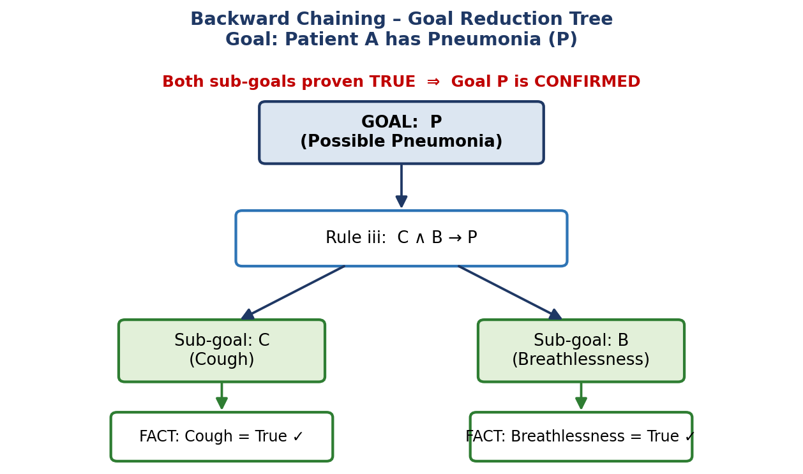
CASE STUDY 2 — Autonomous Traffic Management Agent
Part (a)
Unification of Rule 1 with the given facts:
Rule 1: ∀x Vehicle(x) ∧ EmergencyType(x) → ClearPath(x)
Facts: Vehicle (Ambulance), EmergencyType (Ambulance)

Step | Unification performed | Substitution θ (MGU)
1 | Unify Vehicle(x) with Vehicle (Ambulance) | θ1 = {x / Ambulance}
2 | Apply θ1 to EmergencyType(x) → EmergencyType (Ambulance); matches fact directly | θ2 = {x / Ambulance} (confirmed)
3 | Final MGU for Rule 1 | θ = {x / Ambulance}
Result: Substituting θ into the rule conclusion gives ClearPath (Ambulance) — the rule successfully unifies and fires.
Part (b)
CNF conversion of the rules:
Rule | CNF Clause
Rule 1 | ¬Vehicle(x) ∨ ¬EmergencyType(x) ∨ ClearPath(x)
Rule 2 | ¬ClearPath(x) ∨ GreenSignal(x) (and ¬ClearPath(x) ∨ ¬RedSignal(x))
Rule 3 | ¬Vehicle(x) ∨ ¬Behind (x, y) ∨ ¬GreenSignal(y) ∨ Proceed(x)
Negated Goal | ¬Proceed (CarA)

Resolution steps:
- Resolve Vehicle (Ambulance) with Rule 1 (x/Ambulance) → ¬EmergencyType (Ambulance) ∨ ClearPath (Ambulance)
- Resolve with fact EmergencyType (Ambulance) → ClearPath (Ambulance)
- Resolve ClearPath (Ambulance) with Rule 2 (x/Ambulance) → GreenSignal (Ambulance)
- Resolve Rule 3 (x/CarA, y/Ambulance) with Vehicle (CarA) → ¬Behind (CarA, Ambulance) ∨ ¬GreenSignal (Ambulance) ∨ Proceed (CarA)
- Resolve with fact Behind (CarA, Ambulance) → ¬GreenSignal (Ambulance) ∨ Proceed (CarA)
- Resolve with GreenSignal (Ambulance) (derived above) → Proceed (CarA)
- Resolve Proceed (CarA) with the negated goal ¬Proceed (CarA) → Empty Clause □
Since resolution produces the empty clause, the negated goal leads to a contradiction ⇒ 'Proceed(CarA)' is PROVED TRUE.
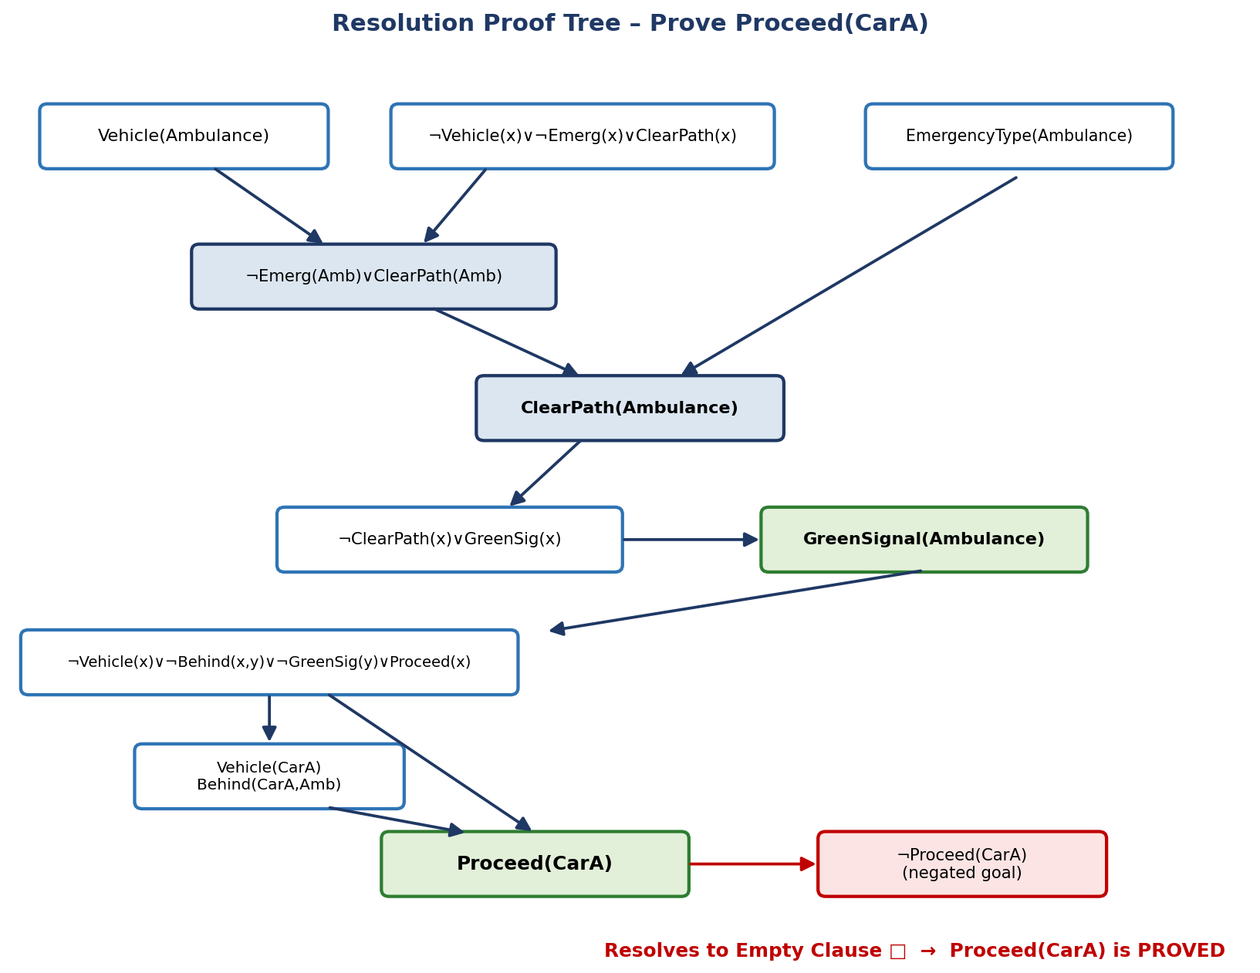
Part (c)
Is the current FOL knowledge base sufficient for two simultaneous emergency vehicles?
Analysis: No — the KB is NOT sufficient. Rule 1 grants ClearPath(x) to any vehicle satisfying Vehicle(x) ∧ EmergencyType(x) independently. If two ambulances (or an ambulance and a fire truck) approach the same intersection simultaneously, both would independently satisfy Rule 1, and Rule 2 would then assert GreenSignal(x) for both — including for conflicting/crossing directions. The KB has no predicate for relative priority, arrival time, or route conflict, so it cannot decide which vehicle should actually get the green signal first.

Additional predicates/rules needed:
- Priority (x, p) — priority level p of emergency vehicle x (e.g., ambulance > fire truck > police escort).
- Conflict (x, y) — true when the paths of x and y intersect.
- ArrivalTime (x, t) or Distance (x, d) — to break ties between same-priority vehicles.
- New rule: ∀x∀y EmergencyType (x) ∧ EmergencyType(y) ∧ Conflict (x, y) ∧ HigherPriority (x, y) → ClearPath(x) ∧ ¬ClearPath(y)
Justification: without such a conflict-resolution rule, the current KB is logically monotonic and would derive ClearPath for every qualifying vehicle, producing an inconsistent traffic state (two green signals on crossing roads) — a genuine gap in the knowledge base.
CASE STUDY 3 — Agricultural Expert Reasoning System
Part (a)
CNF conversion — eliminate implication → move ¬ inward → distribute:
Sentence | Step 1: Eliminate → (A→B ≡ ¬A∨B) | Final CNF
P1: SoilDry → IrrigationNeeded | ¬SoilDry ∨ IrrigationNeeded | ¬SoilDry ∨ IrrigationNeeded
P2: IrrigationNeeded ∧ CropWheat → ApplyDripMethod | ¬(IrrigationNeeded∧CropWheat) ∨ ApplyDripMethod | ¬IrrigationNeeded ∨ ¬CropWheat ∨ ApplyDripMethod
P3: ¬ApplyDripMethod ∧ CropWheat → CropAtRisk | ¬(¬ApplyDripMethod∧CropWheat) ∨ CropAtRisk | ApplyDripMethod ∨ ¬CropWheat ∨ CropAtRisk
Facts: SoilDry, CropWheat | already atomic | SoilDry; CropWheat (unit clauses)
(De Morgan's law ¬(A∧B) ≡ ¬A∨¬B was applied while moving negation inward for P2 and P3; distribution was not further needed since each clause is already a single disjunction.)
Part (b)
Resolution Refutation — prove 'ApplyDripMethod':
- Negate the goal: ¬ApplyDripMethod, and add it to the CNF knowledge base.
- Resolve SoilDry with (¬SoilDry ∨ IrrigationNeeded) → IrrigationNeeded
- Resolve IrrigationNeeded with (¬IrrigationNeeded ∨ ¬CropWheat ∨ ApplyDripMethod) → ¬CropWheat ∨ ApplyDripMethod
- Resolve with fact CropWheat → ApplyDripMethod
- Resolve ApplyDripMethod with the negated goal ¬ApplyDripMethod → Empty Clause □
The derivation of the empty clause proves, by refutation, that ApplyDripMethod logically follows from the KB.
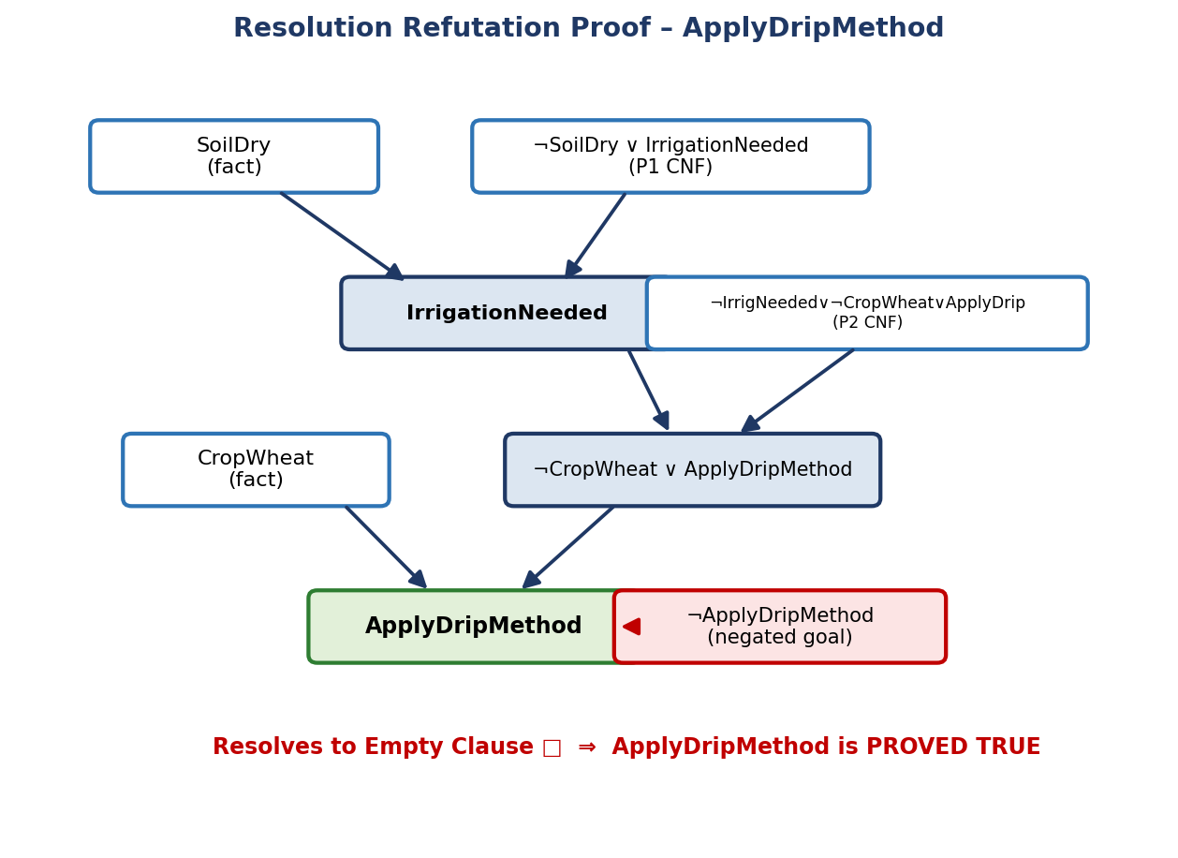
Part (c)
If the fact 'SoilDry' is removed, how do the conclusions change?
- Without SoilDry as a unit clause, the clause (¬SoilDry ∨ IrrigationNeeded) can no longer be resolved down to IrrigationNeeded — so IrrigationNeeded can no longer be proven.
- Consequently, ApplyDripMethod can no longer be derived from P2 either (its antecedent IrrigationNeeded is unproven).
- Under the Closed-World Assumption (CWA) — common in rule-based expert systems — anything that cannot be proven true is treated as false. So ¬ApplyDripMethod is assumed True.
- Applying P3 (¬ApplyDripMethod ∧ CropWheat → CropAtRisk) with ¬ApplyDripMethod = True and CropWheat = True (Modus Ponens) → CropAtRisk is derived.
Conclusion: Yes — under the Closed-World Assumption, 'CropAtRisk' STILL follows (via negation-as-failure), even though 'ApplyDripMethod' no longer does. Under strict open-world FOL semantics, however, neither ApplyDripMethod nor CropAtRisk could be proven, since ¬ApplyDripMethod itself is not formally entailed — the outcome is indeterminate without CWA.
CASE STUDY 4 — Wumpus World Knowledge Agent
Part (a)
Belief state from percepts — applying Modus Ponens:
Percept | Rule Applied (Modus Ponens) | Derived Conclusion
Stench [1,2] | Stench [1,2] → Wumpus adjacent to [1,2] | Wumpus is in {[1,1], [1,3], [2,2]}
Breeze [1,1] | Breeze [1,1] → Pit adjacent to [1,1] | Pit is in {[2,1], [1,2]}
Glitter [2,2] | Glitter [x, y] → Gold at [x, y] | Gold [2,2] is TRUE
All derived conclusions: WumpusAdjacent [1,2] ⇒ Wumpus∈ {[1,1], [1,3], [2,2]}; PitAdjacent [1,1] ⇒ Pit∈ {[2,1], [1,2]}; Gold [2,2] = True.
Part (b)
Forward Chaining — narrowing down Wumpus and Pit locations:
- [1,1] is the agent's starting square and is known safe by convention → eliminate [1,1] from the Wumpus candidate set.
- Remaining Wumpus candidates: {[1,3], [2,2]}.
- [1,2] has already been visited safely (the agent is alive there) → eliminate [1,2] from the Pit candidate set.
- Remaining Pit candidate: {[2,1]} → since it is the only candidate, Pit [2,1] is confirmed.
- Apply Rule 4 (¬Wumpus [x, y] ∧ ¬Pit [x, y] → Safe [x, y]) to all cells not implicated by any Stench/Breeze inference, e.g. [3,1], [2,3], [3,2], [3,3] → marked Safe (Unknown but not threatened).
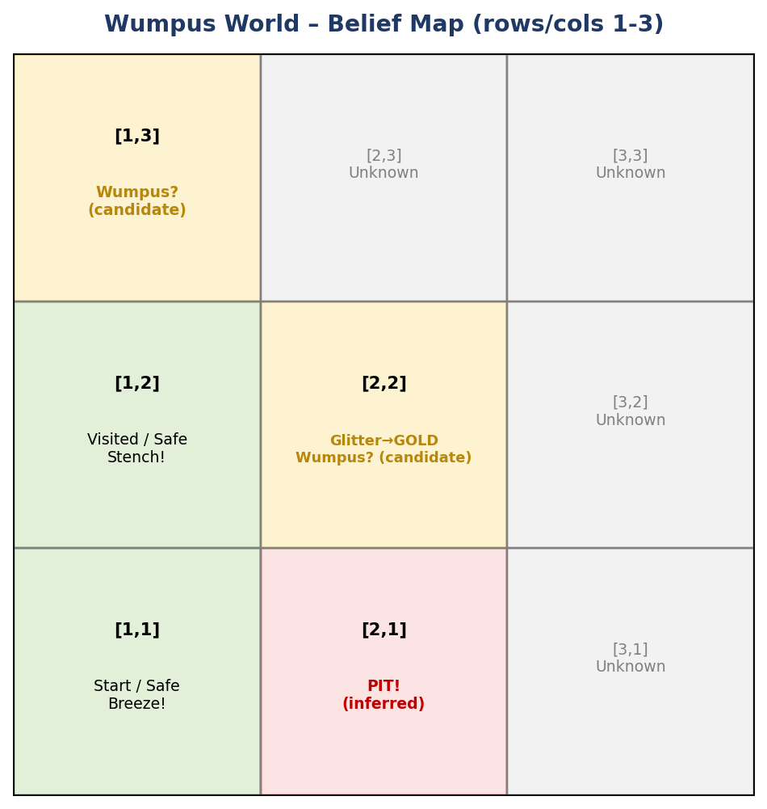
Part (c)
Is the path [1,1] → [1,2] → [2,2] safe to collect the gold?
Cell | Safety Evaluation | Verdict
[1,1] | Starting square, safe by convention | Safe ✓
[1,2] | Already visited without triggering Pit/Wumpus death | Safe ✓
[2,2] | Contains Gold (from Glitter); but still an unresolved Wumpus candidate — [2,2] was not eliminated from the Wumpus set in part (b) | NOT confirmed safe ⚠
Conclusion: The path is safe for its first two steps, but the final step into [2,2] carries residual risk because the Wumpus has only been narrowed to {[1,3], [2,2]} and not fully eliminated from [2,2]. Using logical inference alone (Rule 4 needs ¬Wumpus [x, y] AND ¬Pit [x, y] to certify Safe), [2,2] cannot yet be certified Safe. The agent should gather one more percept (e.g., check for stench while adjacent to [1,3], or use the absence of stench at another neighboring cell) to eliminate the remaining ambiguity before proceeding — entering [2,2] now would be a calculated risk, not a logically guaranteed-safe move.

